**Project Report**

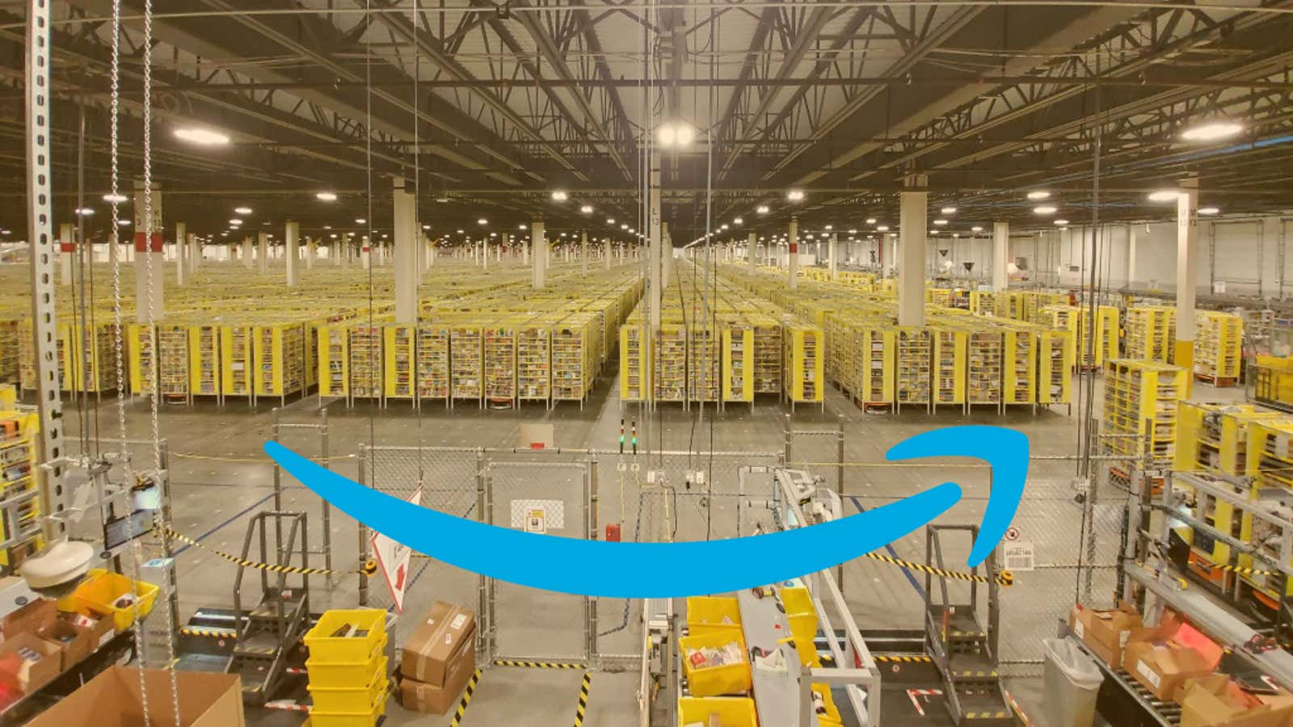

**Data Visualization on**

**Amazon India Warehouse Analytics**

**(From March 2022 to June 2022)**

**Introduction**

In the fast-paced and ever-evolving world of e-commerce, data-driven decision-making has become crucial for businesses to stay competitive and meet customer demands effectively. Amazon India, one of the leading e-commerce giants, understands the importance of leveraging data to optimize its operations and enhance customer satisfaction. To achieve this, Amazon India embarked on a comprehensive analytics project using Tableau to gain insights into its national and international sales performance during the period from March 2022 to June 2022.

The project aimed to utilize the power of Tableau's robust data visualization and analytics capabilities to analyze and interpret data gathered from various Amazon India warehouses across the country and overseas. This period was chosen as it covered an important quarter for the company, encompassing major sales events, seasonal trends, and potential fluctuations in customer behavior.

The key objectives of the Amazon India Warehouse Analytics project were:

1. National Sales Analysis: To comprehensively analyze sales data within India, assessing regional variations, popular product categories, and identifying potential growth opportunities. The project sought to identify best-selling products, peak sales periods, and potential factors influencing sales performance.

2. International Sales Performance: Analyzing sales performance in various countries outside India to understand the impact of global factors, local preferences, and regional dynamics on Amazon's international success. The project aimed to identify top-performing markets, explore cross-border shopping trends, and assess customer satisfaction levels.

To accomplish these objectives, the project team utilized data from various sources, including transaction records, customer feedback, logistics information, and international sales reports. The data was cleansed, transformed, and integrated into Tableau for easy visualization and interpretation.

**Research question and ambition**

1 Regional Sales Patterns: Visualize the sales data to understand which regions within India and in the international market contribute the most to clothing sales. Analyze the reasons behind variations in sales across different regions

2 Price Analysis: Analyze and visualize the price distribution of clothing products in both markets. Determine the price ranges that attract the most sales and compare pricing strategies between the Indian and international markets.

3 Shipping Efficiency: Visualize the shipping status of clothing products in India and internationally to analyze delivery times and identify any disparities in shipping efficiency.

4 Demographic Analysis: Use data visualizations to understand the demographic distribution of customers in India and internationally who purchase clothing products.

5 Size Preference Visualization: Create visualizations to understand the size preferences of customers in different regions and how they vary across clothing categories.

6 Stock Availability Trends: Visualize the availability of clothing stock over time in India and international markets, highlighting any discrepancies or seasonal patterns.

1. Top-Selling Items and Categories: Identify the top-selling clothing items and categories in India and internationally, and visualize their popularity over time..

**Methodology:**

My study included gathering data from a variety of sources. The main data source is Kaggle,

This is data from a business' Amazon Sales in India. There are 3 files in this set. "Amazon Sale Report.csv" will be deemed the main file as it best fits contextually and has the most amount of data. Using column, SKU, this file can be related to two other files "International sale Report.csv" and "Sale Report.csv". "International sale Report.csv" is assumed to be sales made to customers outside of India. "Sale Report.csv" contains additional product information for the SKUs present in the first two sheets.

**Cleaning Data:**

1. Remapping "International sale Report.csv" which is composed of four sheets. The first and fourth sheet are useful and share most columns
2. Removing two redundant columns from the India Sales File
3. Removing one redundant column from the International Sales File
4. Removing one redundant column from the Product Info File
5. Removing empty rows from the Product Info File
6. Renaming two columns in the Product Info File to match the other two files

Reference link for Datasets:

**<https://www.kaggle.com/datasets/thedevastator/unlock-profits-with-e-commerce-sales-data>**

[**https://www.kaggle.com/code/andrewdoner/understanding-and-cleaning-make-use-of-3-sheets**](https://www.kaggle.com/code/andrewdoner/understanding-and-cleaning-make-use-of-3-sheets)

**Analysis:**

1. **Available Stock and Shipping status**

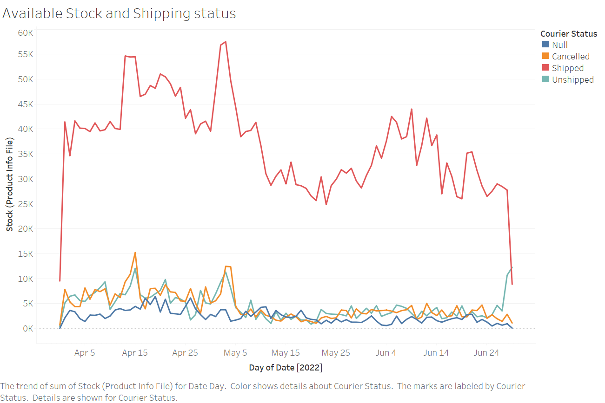

* This visualization helps to compare available stock versus shipping status during those 4 months. Shipping status of clothing products in India and internationally to analyze delivery times and identify any disparities in shipping efficiency

1. **Different clothing and their shipping city**

This Visualize the sales data of different clothing to understand which regions within India contribute the most to clothing sales. And helps Analyze the reasons behind variations in sales across different regions.

1. **Average Price each item in the category**

This average price in each category helps Category Analysis, Visualize the performance of clothing brands and categories on Indian Amazon helps to Identify popular brands and categories in each market and explore reasons for differences.

1. **Price trends of different Clothing**

This visualization captures the different price trends of different clothing, Price analysis and visualize the price distribution of clothing products. Helps to determine the price ranges that attract the most sales and compare pricing strategies between the Indian and international markets.

1. **Size Vs Stock and their Category**

This visualization captures availability stock trends which visualize the availability of clothing stock over time in India and Size Preference visualizations to understand the size preferences of customers in different regions and how they vary across clothing categories.

1. **Percentage Of sales in each state**

This helps us to find performance of each state and Regional Sales Patterns and visualize the sales data to understand which regions within India contribute the most to clothing sales. Analyze the reasons behind variations in sales across different regions.

1. **Top 25 customers based on their Average purchases**

This visualization helps Customer Segmentation Group top customers based on their buying patterns tailor marketing strategies and improve customer retention

**Dashboard 1:**

**Dashboard 2:**

**Conclusions:**

1. **National Sales Performance:**
   * The project identified the top-selling product categories, allowing Amazon India to focus on high-demand products and maximize revenue potential.
   * Regional variations in sales performance were analyzed, enabling the company to devise region-specific strategies to address customer preferences and optimize distribution.
2. **International Sales Insights:**
   * The project uncovered key international markets with high sales volumes, providing Amazon India with opportunities to expand its presence in those regions further.
   * Understanding customer preferences and buying behavior in different countries allowed for more tailored marketing and localization efforts.